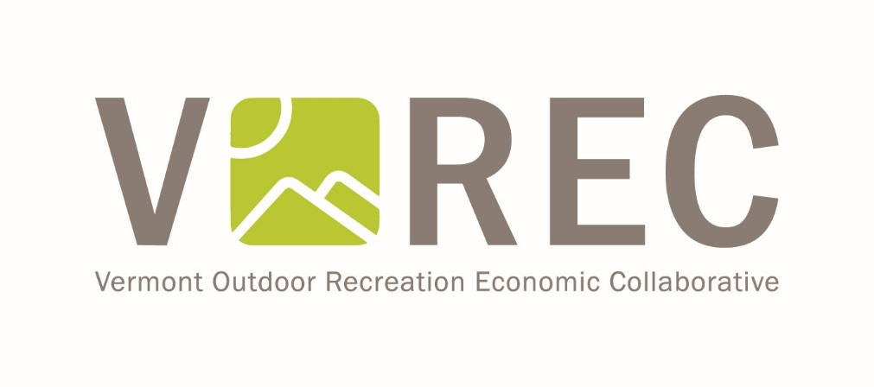

VOREC Community Grant Program
Report to the Legislature

Background
With the issuance of Executive Order No. 11-17, Governor Scott established the Vermont Outdoor Recreation Economic Collaborative (VOREC). The effort is guided by the VOREC steering committee which is made up of Vermont businesses and non-profits including outdoor manufacturers, retailers, brand representatives, trail and user groups, and conservation organizations, as well as state government.
The VOREC steering committee’s purpose is to engage with businesses, government, the nonprofit sector and the public to identify specific outcomes that promote business opportunities, increase participation opportunities, and strengthen the quality and stewardship of our recreational resources, and provide recommendations to the Governor based on that purpose.
As part of that charge, the VOREC steering committee hosted seven public meetings as well as an online survey to gather public input on how to achieve and measure success with VOREC’s objectives. Overwhelmingly, we heard that Vermont communities are primed and ready to embrace outdoor recreation as a cornerstone to their economies. Based on this response, the Governor and the Legislature believed that with some financial incentive we could create Outdoor Recreation Friendly Communities, a pilot program to support communities in their efforts to grow local outdoor recreation economies. This report is meant to convey the results to date of the pilot program associated with that funding.

Development of the Grant Program
In spring of 2018, Forests, Parks and Recreation (FPR) and Agency of Commerce and Community Development (ACCD) staff began collaborating on a grant program structure based on the likely scenario of receiving $100,000 for a pilot program. The staff involved in developing the program have extensive grant administration experience and felt that the goals of the program should reflect the goals of the VOREC initiative: openness, inclusivity, and transparency. Since the beginning, VOREC has embraced the motto, “If you’re outside, you’re in.” Including as many communities in this opportunity while still achieving the outcome of a pilot means striking a fine balance, and the program structure and subsequent grant materials are meant to reflect that balance.
In developing this grant program, it was clear to all that there is a local and national recognition that outdoor recreation can and should be a cornerstone for rural economies. Vermont is one of the first states in the country to create an “office” of outdoor recreation, and is known as a national leader of the Outdoor Recreation Industry Offices (OREC). In Vermont, we have been promoting outdoor recreation as a central player in our economy for a very long time, but now there seems to be an increased enthusiasm for this effort because it’s a strategy that works for small towns and regions both as a central economic sector and one that complements other industries.
The goal of the working group was to receive a wide variety of proposals which could achieve success in the four main pillars of VOREC:
- Grow outdoor recreation related business opportunities
- Increase participation in outdoor recreation activities
- Strengthen the quality and extent of outdoor recreation resources
- Increase stewardship of outdoor recreation resources
A set of selection criteria was developed to reflect these four pillars as well as the factors outlined in the enabling legislation. Existing assets and capacity, planning and environmental stewardship, community support, economic and community need, and existing businesses are all part of the application narrative and will be scored by our ranking committee.
The final application was designed to be simple enough that any community could apply, whether they had professional staff to write the application or not. The Governor announced the launch of the grant program on October 9, 2018 at the Craftsbury Outdoor Center during one of the Capital for a Day events.

Response to Program
From the time that the Governor announced the opportunity, staff received overwhelming interest: many phone calls and emails were received daily. Based on conversations with staff, communities determined whether this program was a good fit for their project needs. Though many did ultimately apply, several communities with eligible projects decided not to apply but want to in the future, which speaks to the interest and need for this type of funding to continue.

Applicants and Potential Projects
On December 14, 2018, 29 applications (of which 28 were eligible) were received from communities in every county of the state, totaling $1,690,120.00 in funding requests. An initial screening process resulted in 10 applications being forwarded to the selection committee. Those communities are highlighted in yellow on the table below.

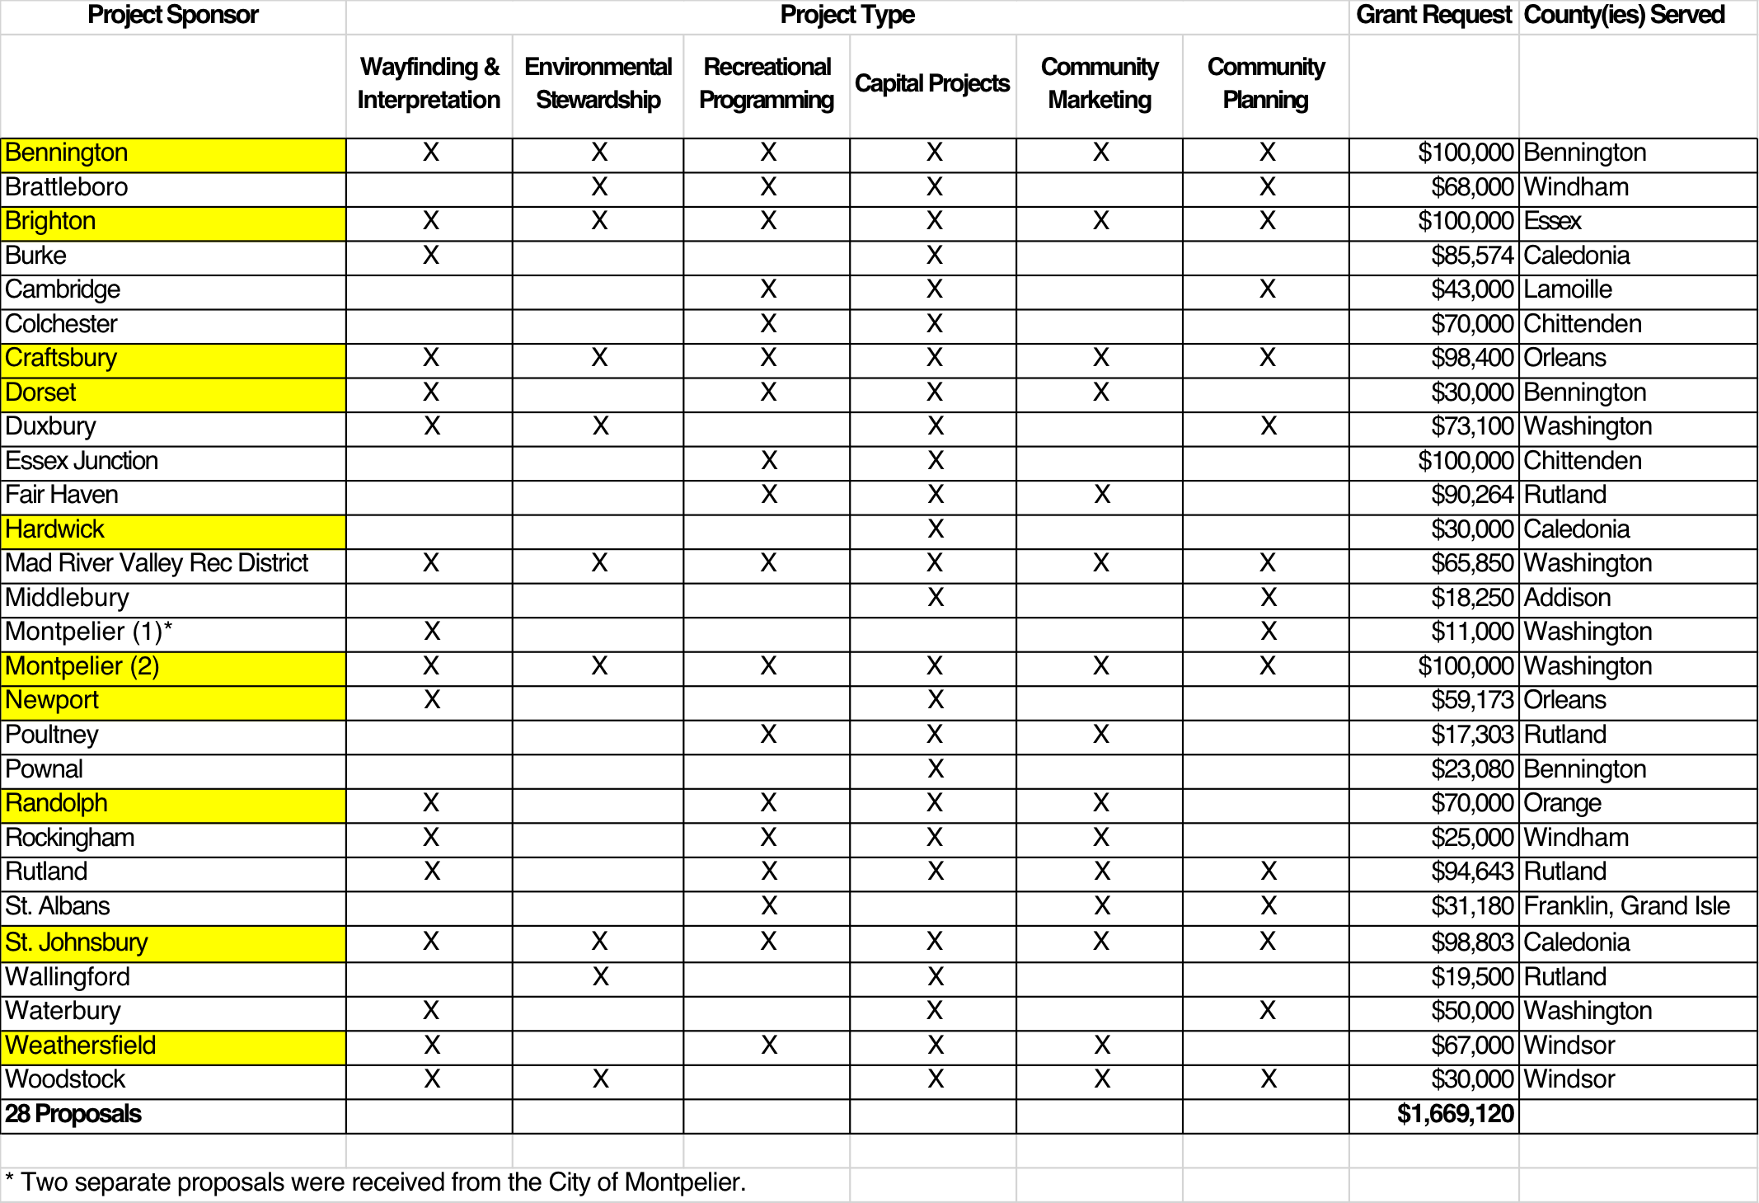

Pilot Communities Selected: Newport and Randolph
The town of Randolph was awarded $65,000 to establish the Randolph region as a year-round, multi-use outdoor recreation destination. The Randolph Outdoor Recreation Development Project will establish a Rochester/Randolph Area Sports Trail Alliance (RASTA) Outdoor HUB in downtown Randolph, will create marketing and signage materials, complete trail design and construction projects, foster new outdoor recreation events, and improve trailhead amenities.
In addition, the city of Newport was awarded $35,000 for trail construction to connect key recreational assets—Prouty Beach and Bluffside Farm—as a critical piece of a larger Waterfront Recreation Trail and Lake Access project.

Randolph’s Accomplishments:
RASTA and Randolph cast a broad net in their VOREC application, with projects ranging from creating a first-ever outdoor recreation trail hub in downtown Randolph, to a new youth mountain bike team, many trail infrastructure improvements, and new trail implementation and events. The Outdoor Hub is slated to open in March of 2020. This will showcase RASTA trails, both winter and summer, with three-dimensional raised relief maps and printed content, along with statewide human-powered recreation information as well.
Randolph has successfully leveraged the VOREC recognition to create other partnerships which helped with forward progress. Projects included partnering with Randolph Area Community Development Corporation to receive the National Life Main Street Grant. RASTA hosted a three-part summer series at the Outdoor Hub combining group mountain bike rides, live local music, and food. RASTA officially partnered with Braintree Hill Events to host the four-part Braintree Bluegrass Brunch series and to implement trail enhancements, along with other outdoor recreation initiatives. The town and RASTA have also partnered with RiseVt to launch the RASTA Ridge Riders youth mountain bike team, which hosted the fifth stop of the VT Youth Cycling race series. Over 200 children from across the state came to Randolph to experience their trail network. Other steps included starting the Vermont Technical College trail network implementation and the formation of their mountain bike club. The town also hosted the Disastour and the Braintree 357 bike races. All the summer events combined drew over 1000 people. RASTA also hosted the October VOREC meeting at the Hub, along with Vermont Recreation and Parks Association quarterly meeting in December.

Newport’s Accomplishments:
The City of Newport was awarded $35,000 for the purpose of building a quarter-mile connector trail between the current Newport Bike Path, and the soon to be constructed Bluffside Farm Trail. Newport Parks & Recreation Director Jessica Booth and Department of Public Works Director Thomas Bernier have worked throughout the summer and fall of 2019 to advance this project.
The city has continued to fundraise for all aspects of the bike path and connector trail to Bluffside Farm. The city has made significant progress on the design, permitting and construction of the Prouty Beach Connector Trail.
Although the path is not complete, the city is already seeing evidence of programmatic activity being stimulated by the new Prouty Beach path. On October 15, 2019, shortly after work began, they received an email from Ryan Anderson, an English Teacher at North Country Union High School (located across the road from Prouty Beach) proposing a community service project to take place. Ryan shared a vision his class had about building a “story walk” for children at the park. “We are hoping to build a story walk in which a picture book is broken down over several stations so the children and their families experience nature between the pages...We are hoping to help with child literacy, foster a love of books and art, get kids and their families outdoors, and highlight the Prouty Beach and campground area,” he said in his message. The Newport Parks Supervisor is working with Ryan’s class to develop this idea throughout the winter in preparation for implementation next summer.
The landscape changed dramatically at Prouty Beach when construction began on segment one of the bike path. What used to be a very gradual, tree-covered slope down to the waterfront, quickly evolved into a winding channel of gentle turns and sweeping side banks. While the project was initially intended to create summer recreation opportunities, it didn’t take long to realize that the city was also inadvertently adding the best, newest sledding hill in Newport! The discovery of this new opportunity prompted them to move Newport’s Winter Festival, (which had been held in a different park for generations) to Prouty Beach where they could expose the new winter asset and incorporate more lake-focused activities into the schedule (like an ice fishing tournament and skating on the bay).
This inspired the partners at the Bluffside Farm to hop on board for the event and host a progressive snowshoe/hike around the waterfront during the Winter Festival with hopes that it could eventually be expanded to include a tour across the Scott’s Cover bridge and onto the farm once infrastructure is in place next winter.
The city plans to resume construction as soon as spring thaw conditions allow. Their goal is to complete the project by June 30, 2020. This will hopefully include paving, and construction of segment #4, depending on when the Vermont Land Trust bridge abutment is finalized.
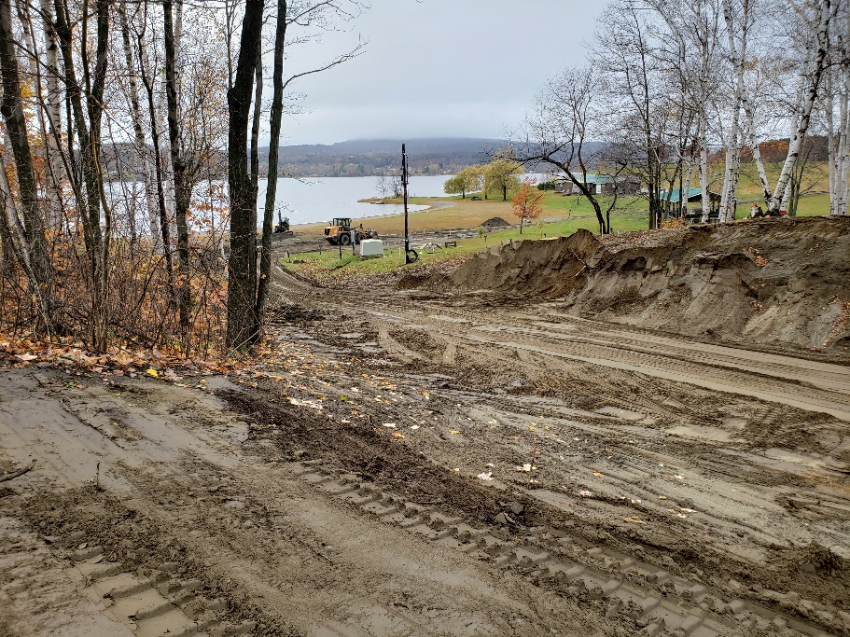

Measurable Outcomes: In Progress
Both Newport and Randolph have begun to compile baseline numbers related to number of users, visitors at recreation assets, tourism expenditures, program participation, and other data. Randolph included some funds in their budget to contract some professional technical assistance, which is forthcoming.

The State has continued to play a role in designing the longer-term designation aspects of the program, and monitoring is crucial to those efforts. Next steps include determining how much support we should provide, such as purchasing and lending trail counters for applicable projects and augmenting professional technical support for monitoring and economic impact documentation.

2020 Grant Round:
On January 20th, 2020, applications for the next round of funding are due. As with last year’s applications, state staff will perform a first round of scoring using a score sheet to manage the number of proposals for review by the Selection Committee. The Selection Committee will then begin reviewing proposals and meet in February for a funding recommendation meeting. Staff will then prepare an award recommendation for VOREC chair and co-chair (FPR Commissioner Michael Snyder and DHCD Commissioner Josh Hanford).
In March we will notify applicants, distribute a press release and update our website. Work on grant agreements will begin.

Next Steps:
An opportunity exists here to encourage communities regardless of selection as the pilot: staff will help unsuccessful project sponsors to seek funding in other available state and private funding programs.
This spring we will begin working with selected pilot communities to implement their goals, assure metrics are being collected which reflect program goals, and provide project support. We will work closely with these pilot communities so that we can replicate their success in other places.
While only a few communities may receive funding in this round, we feel certain that there are projects worthy of future consideration. Additional funding and dedicated staff would surely be met with widespread interest.
We look forward to reporting our progress to the Legislature both this session and next with measurable results of economic growth.

